TO WHOM IT MAY CONCERN

This is to certify that I, Macario Lamsen Guardian of Nicole Adarayan Villa a student of Gordon College, grant this permission for her to undergo On-the-Job Training in the IDESS Interactive Technologies Inc. situated at Unit 8 2nd floor Amires Bldg., Manila avenue corner, Rizal Highway, Subic Bay Freeport Zone, Philippines 2222. I understand and agree that this training is necessary as well as important in honing the skills and work ethics of my child in relation to her course Bachelor of Science in Information Technology being taken under the College of Computer Studies, Gordon College.

I further agree and affirm that Gordon College and IDESS Interactive Technologies Inc. are in no way responsible nor liable to any untoward incident or accident that might happen upon in the course of training.

I also certify that he/she on his/her own free will, signified to me his/her decision to undergo his/her on-the-job training as evidence by her signature affixed below together with my own signature.

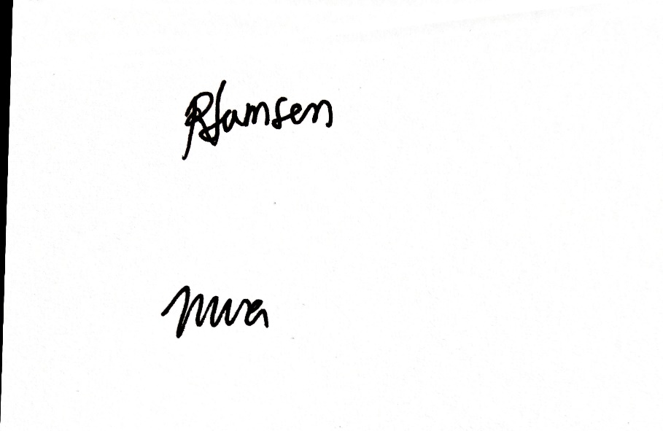

NICOLE ADARAYAN VILLA

Student Trainee

Printed Name and Signature

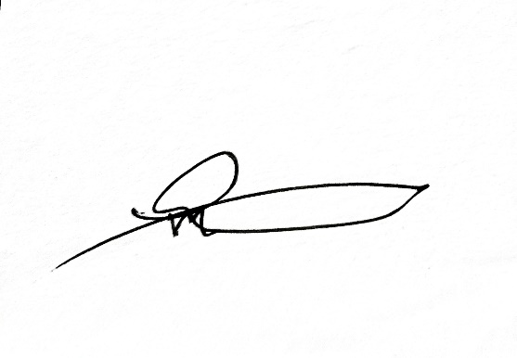

MACARIO L. LAMSEN

Guardian

Printed Name and Signature

February 13, 2023

Ms. Jinalyn R. Rogayan

Admin Officer – HR

IDESS Interactive Technologies Inc.

Unit 8 2nd floor Amires Bldg., Manila avenue corner,

Rizal Highway, Subic Bay Freeport Zone, Philippines 2222.

Dear Madam:

I am 4th year Information Technology student of Gordon College, College of Computer Studies. In partial fulfillment of the requirement of this degree, I am required to have an On-the-Job Training (OJT) for a minimum of 400 hours starting _________________.

I would like to apply as a student trainee in your company because I believe that the training and experience, I will acquire from your company will enrich my knowledge about my course.

Thank you for any consideration and opportunity that you may give to this letter of application.

Very truly yours,

Nicole A. Villa

Nagbalayong, Morong, Bataan

09484088879

Noted:

**Dr. Erlinda S. Casela-Abarintos**

Gordon College